|  |  |  |
| --- | --- | --- |
| **Guide Name** | | **Panel Head** |
|  | Dr. Maivizhi R | Dr Hariharan |
|  |  |  |
|  | **Faculty Advisor** | **Project Domain** |
|  | **Ms.A.L.Amutha** | Research Based |
| M |  |  |
|  | **Student(s) Details: Name** | **Passport size photo(s)** |
|  | 1. Dibyajyoti Ganguly 2. Tarun Negi | C:\Users\HP\Downloads\WhatsApp Image 2023-11-10 at 08.50.01_f0efc0d7.jpg |
|  |  |  |

Registration Number(s)

1.RA2011026010122

2.RA2011026010132

**Email ID(s)&Mobile Number(s)**

|  |  |
| --- | --- |
| 1: dg7255@srmist.edu.in | 2:tn9791@srmist.edu.in |
| 8337090777 | 7985857522 |

**Abstract Architecture Diagram**

***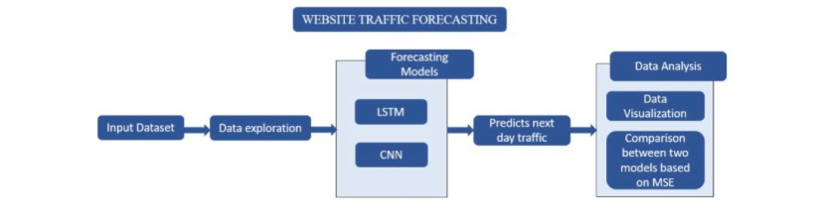***

This project presents a novel approach to network traffic analysis and application detection, leveraging deep learning and recurrent neural networks, particularly Long Short-Term Memory (LSTM) networks. The growing complexity of network traffic, driven by diverse applications and evolving attack vectors, poses significant challenges for network security and performance optimization. The project introduces a classification learning method that represents input features and output labels as two-dimensional images, enabling real-time analysis and classification of network packets into predefined application categories. The proposed scheme achieves high accuracy, reaching 99.82%, while maintaining low complexity. This research has the potential to enhance tools like Wireshark used for packet analysis and monitoring in network environments.

**Significance of the Project Conclusion**

The project's significance lies in its use of deep learning, specifically LSTM networks, to advance network traffic analysis and application detection. By improving the accuracy and efficiency of these tasks, the project contributes to enhanced network security, performance optimization, and real-world applications, making it valuable in today's digital landscape.

In conclusion, this project's use of deep learning, particularly LSTM networks, represents a significant advancement in network traffic analysis and application detection. It offers practical solutions for improved network security, performance optimization, and real-time traffic analysis, contributing to the ongoing evolution of network technology.

**Conference/Journal Publication Details (If Any)**